**Wallet Tutorial**

**Step -1**

First, Users have to visit <https://ico.terragreen.io> and register from the upper left corner.

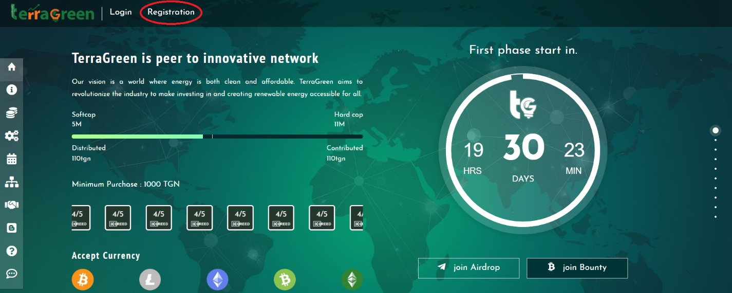

**Step -2**

How to purchase TerraGreen Coins?

Now log in to your account on ICO website.Click on the wallet button from menubar at left side.Deposite whatever currency by which you want to purchase TerraGreen coin.Now go to the dashboard,select currency and buy TGN coin.

**Step -3**

At the end of the ICO,Users will have to submit KYC details from account section located in menubar at left side on ICO website <https://ico.terragreen.io>

**Step -4**

Wallet Address submission from the TerraGreen Wallet

Now,After submitting KYC Users have to visit <https://wallet.terragreen.io> and create account.User will get **unique Log In ID** in email keep it safe without it they can not be able to log in.

Now go to dashboard **click on receive button** to get TerraGreen wallet Address.now at the end of ICO they will have to submit this **TerraGreen wallet Address** to terragreen ICO website in their account to get TGN coins <https://ico.terragreen.io> . that’s it

